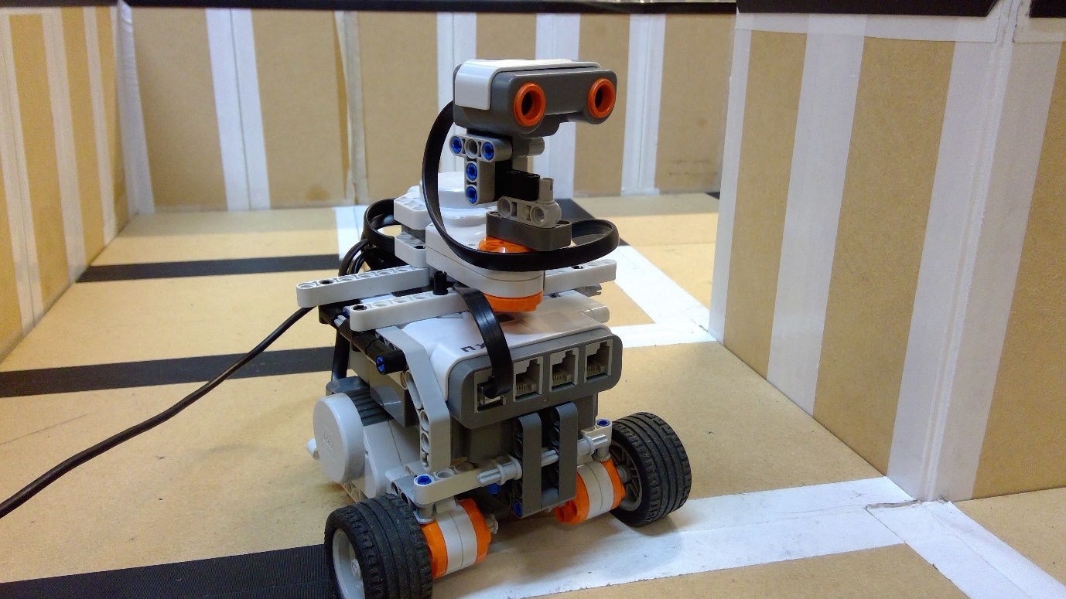

Robotic Systems – Coursework

Sebastian Oakes

2018

**1 - Introduction**

This report details the development of a particle filter localisation system for use with the NXT Mindstorms kit, and highlights the challenges involved with translating algorithms from the simulation setting to the real world.

**2 - Robot Construction**

In order to preserve much of the function of the algorithm developed in earlier work which quickly and accurately determines location within the simulation environment, the robot was designed in order to mimic a point particle where possible; the ultrasound sensor was placed directly over the wheels, in order to ensure the axes of rotation of the sensor and robot body aligned.

With the rest of the body, the aim was to provide a sturdy platform to ensure the flexing of components does not affect movement, as was found to be the case in earlier designs. Further to this, the ultrasound sensor required sufficient clearance from the rest of the body, to ensure readings were not inhibited in any way. This high vantage point also provides the ability to take readings in any direction, something that proves particularly useful for maximising the number of obvious features available to be scanned at any one time.

The castor wheel at the rear of the robot provides little resistance to the two driving wheels, thus making the development of movement functions considerably simpler. The bulk of the robot lies behind the wheels and sensor, proving problematic when making large turns near walls. This issue is largely resolved through the movement decision making tree, explained in section 3.

**3 - Functions for Movement and Turning**

In order to replicate the point like movements and turns of the particles, functions were required that could be called during the localisation procedure as required. The use of two driving wheels, with the axis of rotation directly between them, aims to keep movement algorithms as simple as possible.

After measuring the diameter of the wheels, linear movement can be produced through consideration of the required travel distance, and the circumference of the wheels. Passing a negative value to the function flips the power value sent to the motor, thus reversing the direction of movement.

The turning function required a little more care; a further measurement of the wheel base (distance between the centres of each wheel) allows the required distance of travel to be determined for each wheel, and thus the required number of turns to cover that distance. Each wheel is sent inverted power values, dependent on the turn value passed to the function.

The exact values of measured wheel base and wheel diameter used for the functions required some experimentation to ensure the required movements were carried out. Since the wheels are not contact the floor at a single point, it becomes difficult to determine the exact distance from wheel to the centre of rotation. Further to this, the wheels are not solid, and so deform under load. In order to account for these issues, trials were carried out, varying the wheel diameter and wheel base values until physical movements and turns matched the function input.

**4 - Localisation Procedure.**

In order to localise the robot within the arena, a particle filter was used to iteratively move towards a firm estimate of the robot position, with the following procedure:

1. Particles are first distributed randomly within the virtual arena, with equal weightings.
2. The robot makes a movement, and the particles replicate this movement, with movement noise added. Any particles that move outside the arena are placed back inside, at a random position. The robot will first check that the minimum distance reading is not below a certain proximity threshold, and if so, the robot will turn towards the minimum, and back away a specified amount. If this condition is not met, the robot will make one of two moves; move a fraction of the largest distance reading, in said direction, or make a 45 degree turn (in a random direction) and move a fraction of the minimum distance reading (to avoid collision).
3. The robot takes an ultrasound reading, and all particles take a virtual reading, to produce an Nx1 size vector, where N is the number of individual ultrasound distance readings (the specifics of the type of reading will be covered later). The two are then compared, by root mean squared error calculation between the vector elements.
4. The particles are then weighted, based on the gaussian probability function; high weightings are given to those particles for which the virtual reading most closely matches the real ultrasound, and are ths more likely candidates for the actual robot position. The particles are then resampled based on these weightings, with more particles placed on the highly weighted previous particle positions.
5. Steps 2-4 are then repeated, until the mean standard deviation of positions for the top candidates drops below a certain value

**5 - Initial Testing and subsequent complications**

Within the simulation environment, this algorithm proves highly effective, but translation into a real-world system proved difficult. The ultrasound sensor is far from an ideal sensor; though given a quoted accuracy of ±1cm, such low error could only be achieved on large, flat surfaces, with the sensor almost normal to the surface. Attempts to measure distances to walls at a steep angle to the sensor line of sight yielded hugely varied results.

The complex dynamics of sound movement adds further complications, with reflections from other surfaces within the arena likely causing a great deal of interference with the desired distance measurement. It was quickly determined that the ultrasound did not deal with corners effectively; making measurements past an (inside) corner caused the sensor to return a value matching the corner distance, an unsurprising result considering the cone-like spread of ultrasound waves from the device. Should the robot be close to a corner, and facing it directly, there is the possibility of returning maximum values (255) due to the emitted sound hitting one edge of the corner, and never returning to the detector.

Early attempts at localising utilised a six-point ultrasound measurement, thus replicating the original ultraScan function used within the simulator. This alone proved highly ineffective for localisation. Due to the aforementioned issues with inaccuracy when the ultrasound-to-wall angle of incidence was too steep, returned distance readings often did not accurately reflect the arena position.

Though some good results could occasionally be obtained, this was usually circumstantial; certain sections of the arena appear to prove easier to localise within.

**6 – Improved Localisation**

To improve upon the localisation process, a different approach is taken. A new scan function is used, to create a continuous distribution of distance readings over 360 degrees. The distribution this produces acts an improved location signature for a position in the arena, capturing many of the obvious features of the surroundings. By replicating this scan with the virtual particle scan, the two distributions can be compared (through the same process as previously), producing a number denoting the level of fit between the two.

Though this process is still subject to the issues with ultrasound that plagued the previous six-point approach, the increased wealth of information about the surroundings creates highly unique location signatures for each position in the map, and decreases the chances of weighting incorrectly positioned particles highly.

Some example distributions are displayed in figure 1, and highlight some of the adjustments made to the distributions to improve the comparison procedure. The first image shows raw data, and highlights the noisiness of the sensor readings, which often create large spikes in the data that do not relate to any physical feature. In order to improve comparison, Savitsky-Golay filtering was used on both distributions to smooth out the features, as in the second image. Though this removes distinctive features that relate to physical aspects of the arena (such as inside and outside corners), these features are often not discernible in sensor reading. Image three highlights a correction made to the sensor distribution; unexpectedly, a constant systematic error was present, offsetting the two readings, thought to be due to a delay in the command to take ultrasound readings. This was easily dealt with using the ‘circShift ‘function within MatLab to shift vector elements by a specified amount.

**7 - Conclusions**

The robustness of the localisation method will likely depend on the type of arena; as was consistently found in testing, certain features cause huge problems. Inside corners have proved troublesome, often causing excessively large distance measurements, and on occasion trapping the robot, since the robot is designed to move into space.

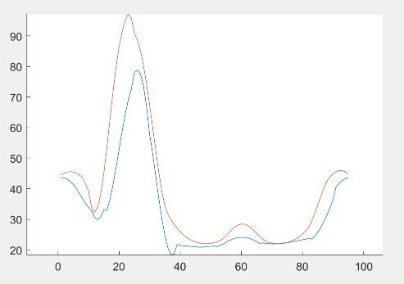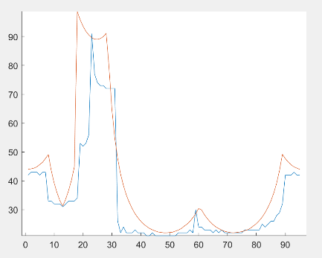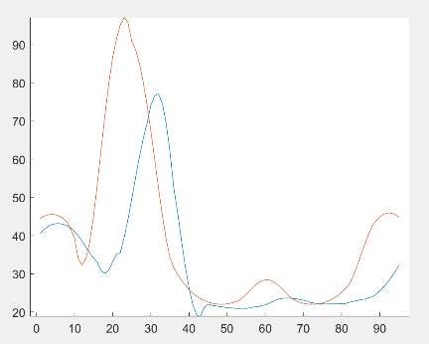

Figure 1 -Example distributions from the continuous ultrasound measurements. Particle measurements displayed in orange, robot measurements in blue. Here, the particle and robot have been placed at the same arena location

Further to this, the particles are unaffected by the measurements made past a corner. In order to deal with this, particle measurements could be redesigned to take the shortest reading from a cone-like spread in the specified direction, thus replicating the spread of sound with distance. The exact effectiveness of this would need to be tested, but it may be able to replicate sensor measurements, thus improving the fit between virtual and sensor location signatures.